**TEXAS INTERNATIONAL COLLEGE**

**TRIBHUVAN UNIVERSITY**

**FACULTY OF HUMANITIES AND SOCIAL SCIENCE**



**A**

**Project Report**

**On**

**DOCTOR APPOINTMENT**

**Submitted to**

**Department of Computer Application**

**Texas International College, Mitrapark, Kathmandu**

***In partial fulfillment of the requirements for the Bachelor in computer application***

***Submitted By***

Name: Niraj Paudel

TU Reg. No: 6-2-926-11-2020

Name: Rista Kafle

TU Reg. No: 6-2-926-20-2020

**TEXAS INTERNATIONAL COLLEGE**

**TRIBHUVAN UNIVERSITY**

**FACULTY OF HUMANITIES AND SOCIAL SCIENCE**



# SUPERVISOR’S RECOMMENDATION

We hereby recommend that this project is prepared by Niraj Paudel and Rista Kafle under supervision by Mr. Suman Thapaliya entitled “**DOCTOR’ APPOINTEMENT”** in partial fulfillment of the requirements for the degree of Bachelor of Computer Application be processed for the evaluation.

Suman Thapaliya

Designation

# LETTER OF APPROVAL

This is to certify that this project is prepared by Niraj Paudel (6-2-926-11-2020) and Rista Kafle (6-2-926-20-2020) entitled “**DOCTOR APPOINTMENT**” in partial fulfillment of the requirements for the degree of Bachelor in Computer Application has been evaluated. In our opinion it is satisfactory in the scope and quality as a project for the required degree.

Suman Thapaliya Omkar Basnet

Project Supervisor HOD

BCA Department

TIC

Internal Examiner External Examiner

Texas Int’l College Tribhuvan University

Mitrapark,Kathmandu Kritipur,Kathmandu

**Abstract**

***Doctor appointment*** is web-based ***appointment System*** which provides patient to book their appointment to visit the doctor. It’s a web application that helps patient to get services without traveling or step out of their home for appointment.

We provide a concise overview of a typical doctor appointment, outlining its key components and the importance of effective communication between patients and healthcare providers. A doctor’s appointment serves as a vital interaction between a patient and their healthcare professional, facilitating the assessment, diagnosis, and treatment of medical conditions.

# **ACKNOWLEDGEMEN**T

We are very grateful to the department of computer application. Texas Int’l College for providing us an opportunity to work on a major project as part of our second-year project. We are delighted to express our deep sense of gratitude and indebtedness to our learned supervisor Mr. Suman Thapaliya, Head of department at Texas Int’l College for his invaluable guidance, encouragement and even monitoring to spare time despite his busy schedule for project’s progress reviews.

Our special thanks go to our friends and everyone who directly and indirectly extended their hands in making this project success.

Sincerely,

Niraj Paudel (Reg No : 6-2-926-11-2020)

Rista Kafle (Reg No : 6-2-926-20-2020)

**LISTS OF ABBREVIATIONS**

CRUD Create, Read, update, and delete.

CSS Cascading Style Sheet

DFD Data Flow Diagram

ERD Entity Relationship Diagram

JS Java Script

MongoDB Database

Node JS Backend

# CHAPTER 1: INTRODUCTION

## Introduction

# Doctor appointment is an arrangement to meet the doctor and patient at a particular time in the clinic or a hospital. It’s an innovative web-based platform designed to simplify the process of scheduling and managing medical appointments for patients, doctors, and administrators. This system aims to bridge the gap between healthcare providers and patients, ensuring timely access to medical consultations and facilitating the exchange of crucial medical information.

## Problems Statement

Traditional appointment scheduling in healthcare settings often leads to inefficiencies, long waiting times, and missed opportunities for both patients and doctors. Patients must call the doctor's office, wait on hold, and then schedule an appointment that is often several weeks away. In some cases, patients may even have to physically go to the doctor's office to schedule an appointment.

## . Objectives

The system aims to help patients to make appointments online through the internet and track their records through it. With the increase in the number of patients visiting, it has become difficult to manage the appointment system manually. For the receptionist it makes it easy to set the date and time for the treatment of the patient to the relevant doctor.

* To help doctors and other healthcare providers manage their schedules efficiently and reduce scheduling conflicts or overbooking.
* To Ensure the privacy and security of patient information.
* To Allow patients to reschedule or cancel appointments as needed.

## Scope and Limitations

**Scope:**

* The system will allow patients to register, log in, and book appointments with available doctors.
* Patients can view their past and upcoming appointments and access medical reports.
* Doctors can log in, view their schedule, access patient information, and upload medical reports.
* The admin can manage doctor schedules, confirm patient appointments, and oversee the system's functioning.
* The system will be accessible from desktop and mobile devices for user convenience.

**Limitations:**

* The system will not handle online payment for appointments or medical services.
* Communication between patients and doctors will primarily occur during in-person consultations.
* The system will not support video or telemedicine appointments.
* The system may not integrate with electronic health record (EHR) systems of healthcare institutions.
  1. **Report Organization**

**Introduction**

This chapter deals with the introduction of system with its objectives and limitation along with the reason why the system is made.

**Background Study and literature Review**

This chapter summarizes the work that has been carried out in the field of data mining and describes the features of some existing applications related to the Doctor appointment management system.

**Implementation and Testing**

This chapter emphasizes tools used in system development, implementing details and result of test performed.

**Conclusion and Future Recommendation**

This chapter highlights summary of lesion learnt, outcome and conclusion of the whole project and explain what have been done and what further improvement could be done.

# CHAPTER 2: BACKGROUND STUDY

## Literature Review

In recent years, the integration of technology into the healthcare sector has led to the development of various doctor appointment systems aiming to improve patient access and streamline healthcare services. The literature review focuses on the existing research and studies related to doctor appointment systems, highlighting their features, benefits, and challenges.

## Study of Existing System

* + 1. **Merodoctor:**

It is a telemedicine platform that allows patients to consult with doctors online. It provides access to licensed doctors and specialists for a range of medical issues. Patients can schedule appointments and access consultations through the Merodoctor website. Patients can search for and select doctors based on criteria such as specialization, location, availability, and ratings.

**2.2.2. Doctor on Demand:**

Doctor on Demand is a telemedicine platform that provides virtual medical consultations with licensed doctors, psychologists, and psychiatrists through video appointments. The platform accepts many major insurance plans and offers affordable out-of-pocket pricing for those without insurance coverage. It also provides virtual consultations with licensed psychologists and psychiatrists for mental health concerns.

# CHAPTER 3: SYSTEM ANALYSIS AND DESIGN

## 3.1. System Analysis

**3.1.1. Requirement Analysis**

* 1. 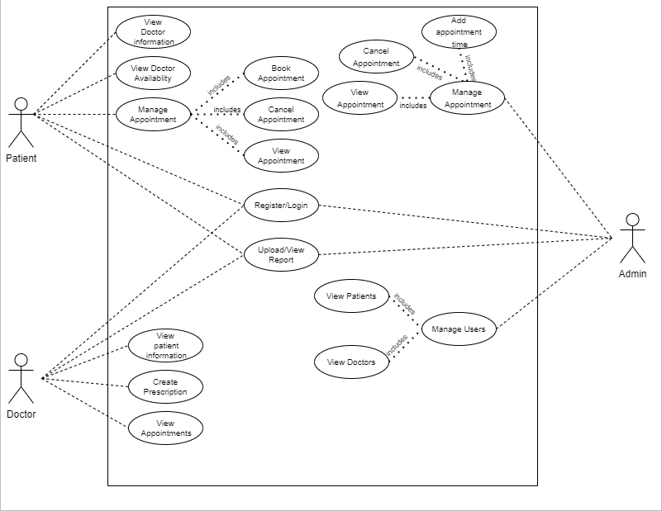**Functional Requirement**

**Fig 1: Use Case diagram for Doctor Appointment**

1. List of functional requirements.

|  |  |  |
| --- | --- | --- |
| Requirement ID | Functional Requirement | Description |
| FR1 | Register and Login |  |
| FR2 | Doctor Information |  |
| FR3 | Patient Information |  |
| FR4 | Appoint Doctor |  |
| FR5 | See Appointment |  |
| FR6 | Set Appointment |  |

* 1. **Non-functional Requirement**
* Performance: Specifies how well the system should perform in terms of speed, response time, throughput, and resource utilization. For example, a requirement might state that the system should respond to user input within 2 seconds.
* Scalability: Describes the system's ability to handle increased loads as the user base or data volume grows. It may involve aspects like the number of concurrent users the system can support or the ability to add more servers to handle increasing demand.
* Reliability: Refers to the system's ability to maintain its functionality over time and avoid failures. This requirement might include metrics such as mean time between failures (MTBF) or mean time to repair (MTTR).
* Availability: Specifies the percentage of time the system needs to be operational and accessible to users. For example, a requirement might state that the system must be available at least 99.9% of the time during business hours.
* Security: Covers measures to protect the system and its data from unauthorized access, data breaches, and cyber-attacks. This may involve encryption, authentication, and access control requirements.

**3.1.2. Feasibility Analysis**

### I. Technical feasibility:

For a seamless user experience, our project designs the UI in HTML, CSS, and JavaScript. We create a dependable and effective DBMS utilizing NodeJS and MongoDB to store and retrieve data, including user profiles and job postings, and to provide easy access to information.

• Software

• Hardware

• All devices support

### Operational feasibility

Users can browse the products from our website but to purchase them they need login to our system. To register, users need to complete all the requirements and pass all the validations and after the registration user can login to their dashboard and buy the products and use all the facilities.

### Economic feasibility:

The cost and benefits of the proposed system are determined by economic viability. A project is economically feasible if its development costs are less than its anticipated costs. These advantages and disadvantages may be concrete or intangible. The project's cost can be easily estimated because there is little chance of intangible costs, but our initiative offers services at no cost.

### Iv. Schedule

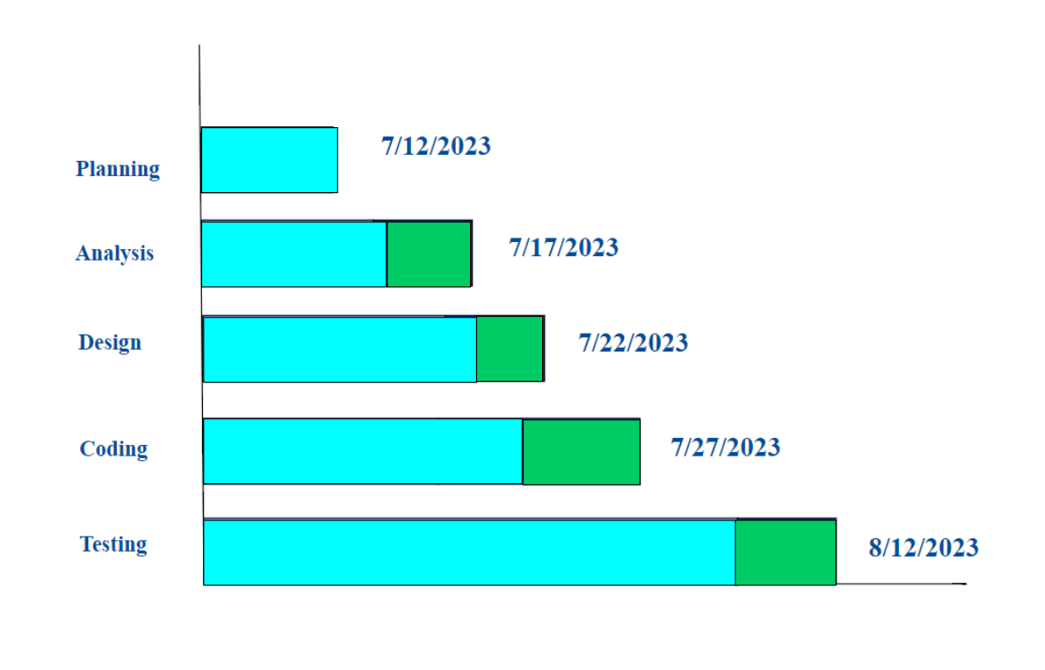

**Fig 2: Gantt Chart diagram for Doctor Appointment**

3.1.3 Data Modeling

**Fig 3:ER diagram for Doctor Appointment**

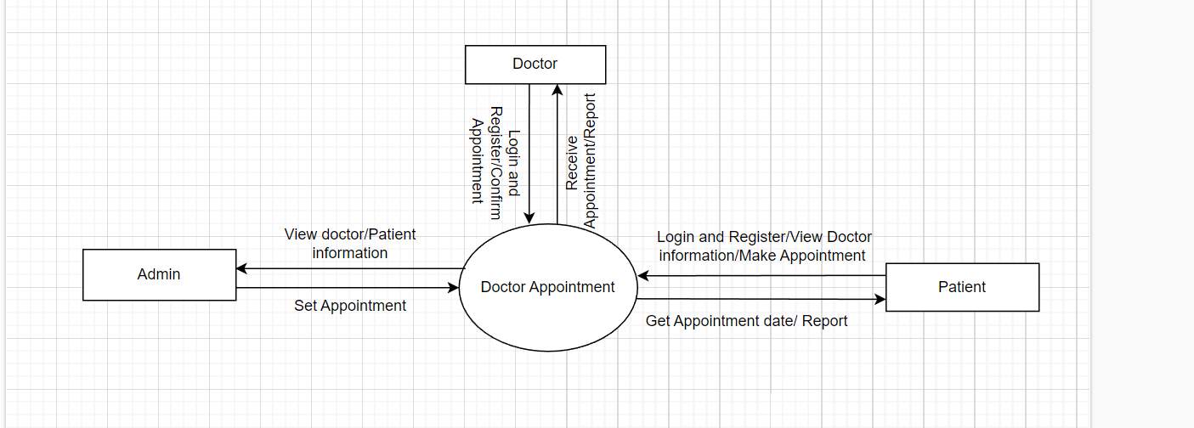3.1.4. Process Schema Modeling

**Fig: Context Diagram**

**Fig: Data Flow Diagram for Level 0**

**3.2 SYSTEM DESIGN**

### 3.2.1. Architectural Design

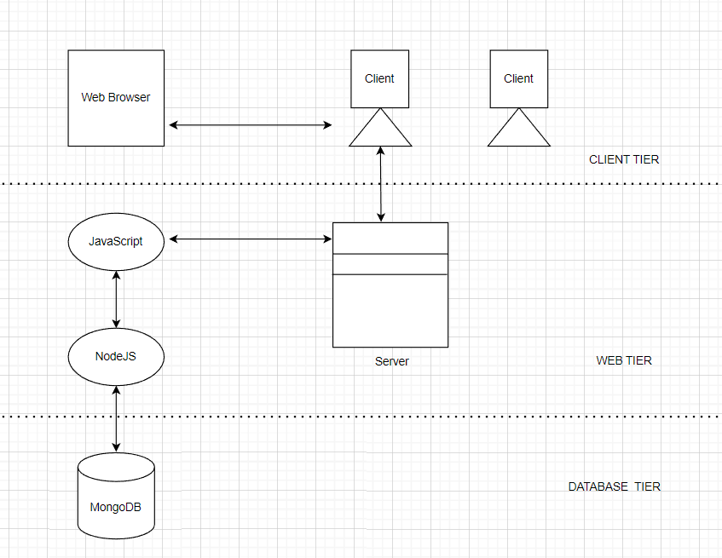

### 3.2.2. Database Schema Design

### 3.2.2.1 Database Schema

### 3.2.3 Interface Design

# CHAPTER 4: IMPLEMENTATION AND TESTING

## 4.1. Implementation

## 4.1.1. Tools Used (CASE tools, Programming Languages, Database platforms)

### 4.1.2 Implementation Details of Modules (Description of procedures/functions)